Fast

**National University of Computer and Emerging Sciences, Karachi**

**FAST School of Computing  
Quiz # 1  
April 4, 2022**

|  |  |  |
| --- | --- | --- |
| **Course Code: CS3005** | **Course Name: Theory of Automata** | |
| **Instructor Name: Mr. Musawar Ali** | | |
| **Student Roll No:** | | **Section No: C** |

**Instructions:**

* Read each question completely before answering it. There are **4 questions** on **2 pages.**
* In case of any ambiguity, you may make assumption. But your assumption should not contradict any statement in the question paper.
* **Cutting and over-writing is strictly discouraged.**
* **Answer your questions with proper reasons to get full credit.**
* **Solve this quiz on extra sheets provided to you.**

**________________________________________________________________________________________**

**Total Time**: 30 minutes **Maximum Points**: 30

**Question # 1 (5 Points)** Minimize the DFA mentioned in **Fig. 1** using any method of your choice.

**Question # 2 (5 Points)** Perform union on DFAs mentioned in **Fig. 1** and **Fig. 2** using kleen’s theorem.

**Question # 3 (5+5 Points)** Apply pumping on language to prove that this is not regular language. Also write 2 languages which fall in this category but are regular according you’re thinking.

**Question # 4 (5 Points)** Convert the Machine mentioned in Fig.3 to its equivalent machine.

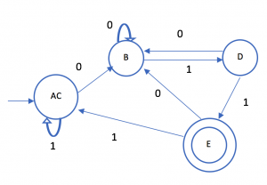 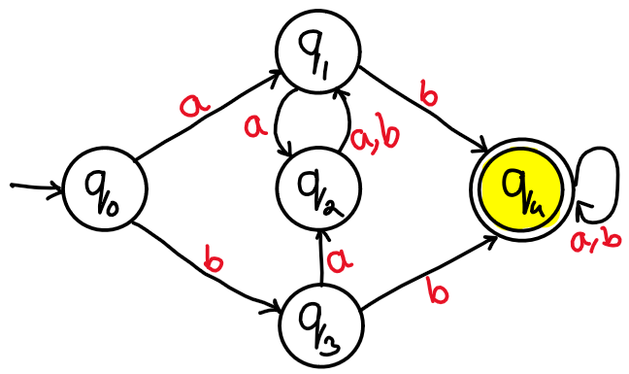

**Fig.1**  **Fig.2**

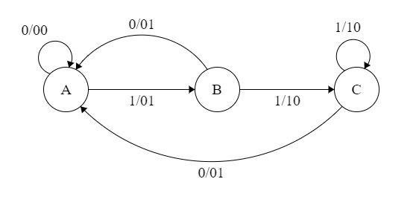

**Fig.3**